So you have bought a Mac , what can you do to make the most of it ? Well how about using some of its Mac Exclusive Apps designed from the ground up to run perfectly on a Mac.

Applications made for certain hardware are always optimised to the core & when the developers are the hardware engineers i.e. Apps Made by Apple. They have certain degree of quality which the fragmented Operating system like the Windows & Ubuntu Computer Users could never achieve. These Applications are tailored for optimised battery life , perfect pixel to pixel ratio applications ( supports Retina display ) etc.

[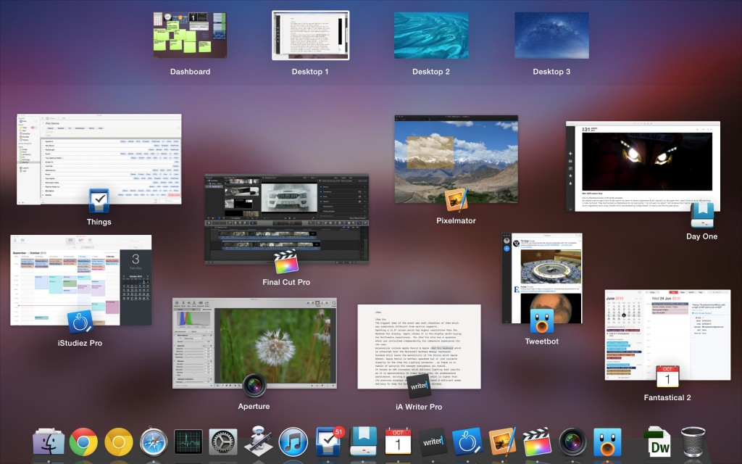](https://www.firstuploads.com/wp-content/uploads/2015/10/Screen-Shot-2015-10-01-at-3.42.25-pm.jpeg)

We recommend these applications as they give some extra value of owing a Mac rather than just an impressive Hardware. These software lures other non mac users to own a Mac.

The whole list consist of Premium applications which could be helpful in day to day life activities.

Yes Premium comes at a price & all these applications comes at a premium price. Often use the trials of the software & then when you feel the need of the software you could always purchase the license for using it.

[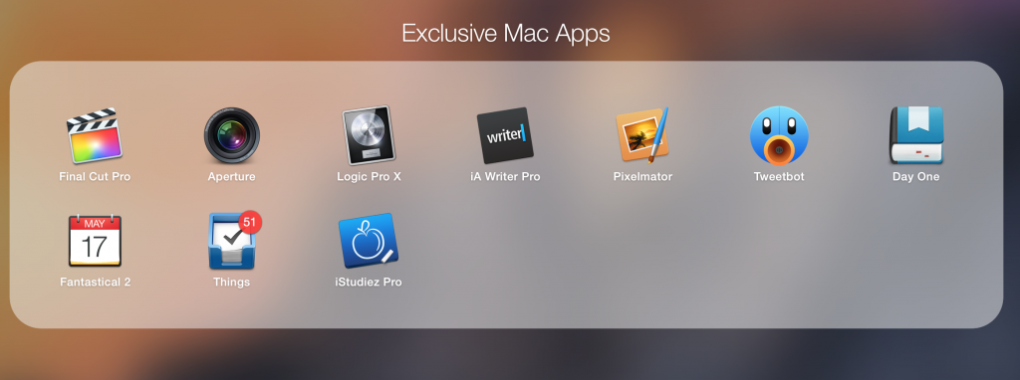](https://www.firstuploads.com/wp-content/uploads/2015/10/Screen-Shot-2015-10-01-at-3.37.56-pm1.png)

We all love applications supported by Mac App Store. The list contains applications which are also Multi platform applications but only under Apple Ecosystem including “iPhone” & “iPad”. We do encourage to at least try any of these applications or even buy the application if you love it.

***Disclaimer****: Our Ratings for Top Ten applications are not biased or favored to any specific application. We did not receive any gifts or any money for favoring these applications in the top ten exclusive applications.*

**Things**

This software is by far the best “To Do list “ Application I have ever used.

What makes it different from its competitors is the ability to create projects for tasks.

Also each task can be given any custom tags we want with the day of reminders to be followed with the task.

It works great with importing “Reminder” application reminders into its own list & also supports Siri + Reminder Import to Things.

We have included a number of screenshots so that you could easily determine the real value of this application.

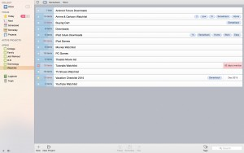

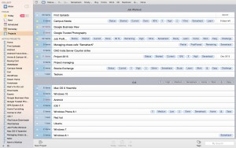

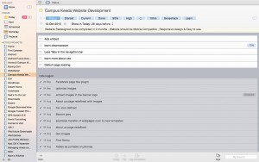

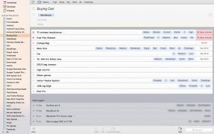

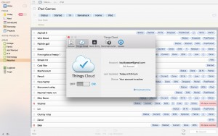

Things Cloud

It has application support on iPhone , iPad & Mac OS X.

**Application Link:**

<https://culturedcode.com/things/>

**Day One**

They say you should always keep a log of things or keep a journal of everyday life. Base on that simple fact this application improves it further on your personal diary or journal to a next level.

This application does so many things better than its competitors with features included just for improving the user experience while reading the journal again after some time.

It preserves the nostalgia in a digital form by embedding “Activities , GPS Coordinates locations , Weather of that day , Photos” etc.

It also supports its own Personal cloud platform for publishing personal journals on the internet with just one click.

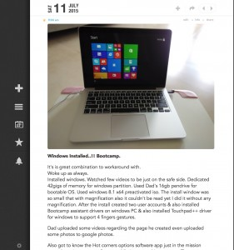

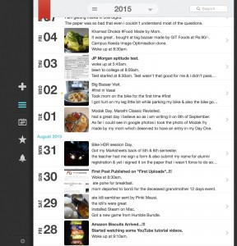

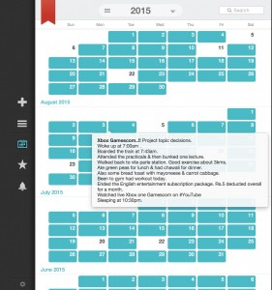

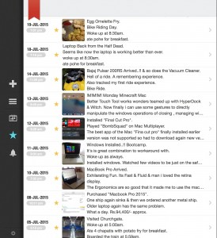

It is currently supported only on iPhone , iPad & Mac OS X.

**Application Link:**

<http://dayoneapp.com/>

**Final Cut Pro**

[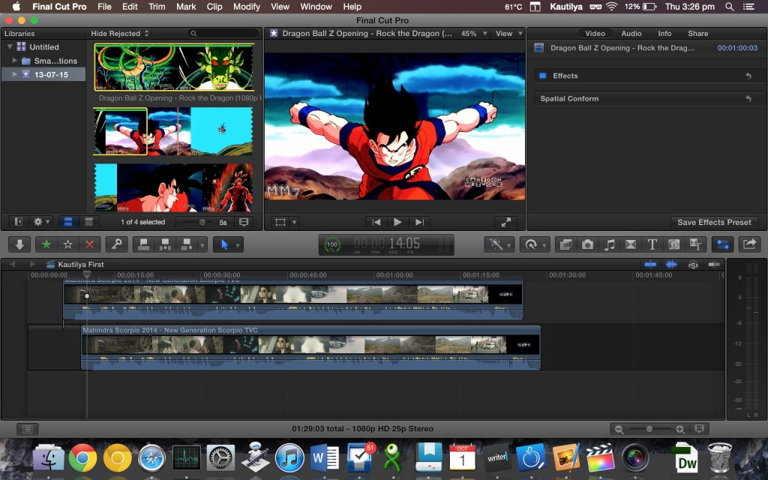](https://www.firstuploads.com/wp-content/uploads/2015/10/Screen-Shot-2015-10-01-at-3.26.44-pm.jpeg)

The reason why videophile or Video Professionals buy a Mac is to get their hands dirty on its one of industry standard of Video Editing tools available.

The name itself lures out the artists who are willing to spend that hefty price tag of $399 for making their videos on the Internet worth watching.

All the top Video industry officials uses this software for making a videos which stand out from others.

It is purely designed around Mac Hardware & also supports the Retina Resolution of the Macbook Pro. You can edit 1080p video pixel by pixel 1:1 ratio on the Macbook Pro & this have space left for other tools on the left hand side panel.

[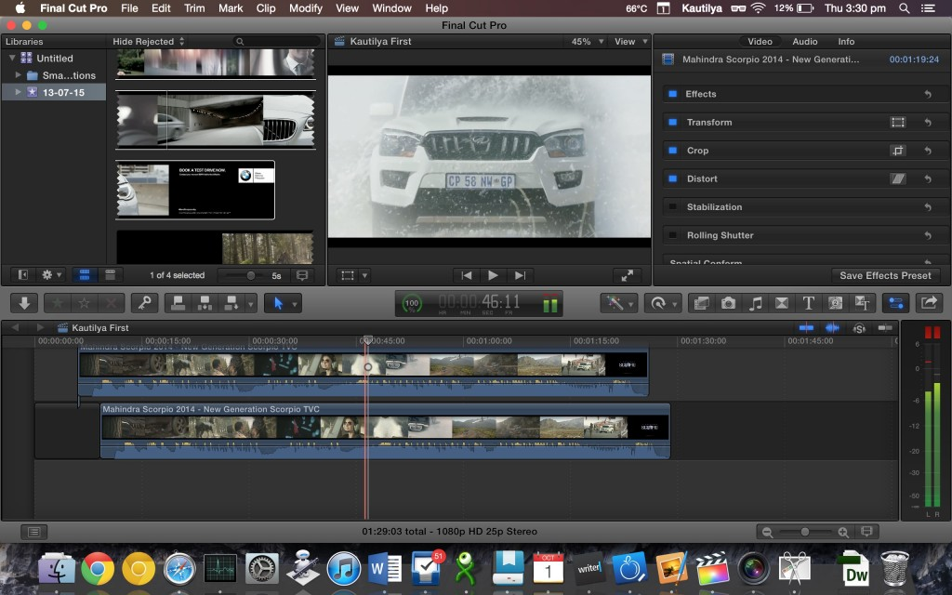](https://www.firstuploads.com/wp-content/uploads/2015/10/Screen-Shot-2015-10-01-at-3.30.25-pm.jpeg)

It also uses Dedicated Graphic cards for extra juice out of the video processing & it has support for faster SSD speeds. So all the seeks, thumnail generation & grubs are lighting fast.

In Mac OS X El Capitan they also have support for Direct API Metal for Mac Applications. Which supposedly gives better draw calls from dedicated GPU thus leading to faster video processing.

Less overhead for CPU with GPU communications using Metal API developed by Apple for latest OS-X.

As Final Cut Pro is made by Apple , it will always receive the better treatment compared to other softwares.

Professional grade video editing software with 8 live cameras viewer  & also support of editing Uncompressed 4k at 60Fps videos all at the expense of beefy hardware & big bucks.

[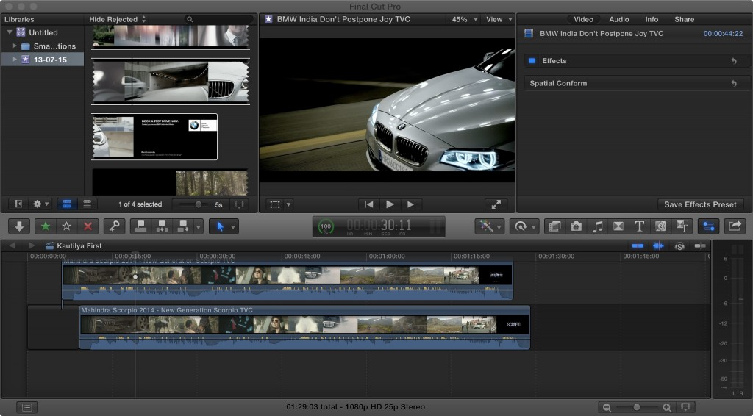](https://www.firstuploads.com/wp-content/uploads/2015/10/final-cut-pro-bmw.jpeg)

**Application Link:**

<http://www.apple.com/us/final-cut-pro/>

**Logic Pro X**

[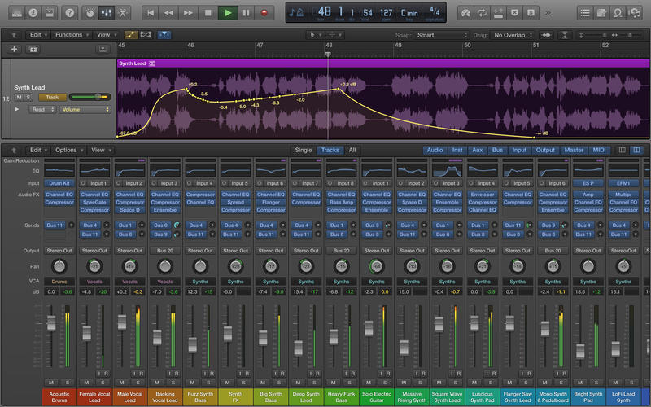](https://www.firstuploads.com/wp-content/uploads/2015/10/logic.jpeg)

If you are in the advent of making digital music , Logic Pro X is by far the most versatile & robust audio creation & editing software out there.

Now I am no judge to making professional audio but the jury is out & it has already been established that “Logic Pro X” is the software to have for making wonderful Audio Creations.

This software also has a hefty price tag of $299 & it also includes various sample audio tracks for making your project sound wonderful.

[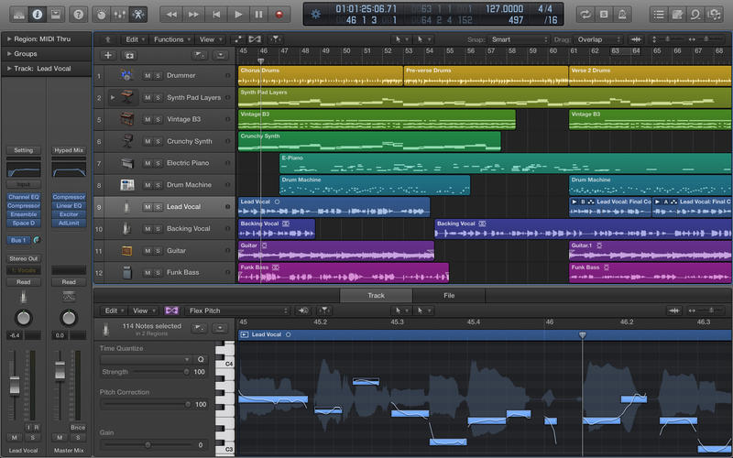](https://www.firstuploads.com/wp-content/uploads/2015/10/logic-pro-x.jpeg)

**Application Link:**

<http://www.apple.com/us/logic-pro/>

**Aperture**

[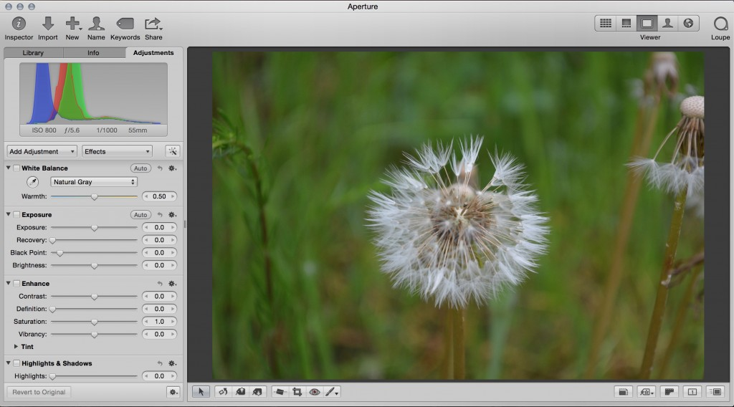](https://www.firstuploads.com/wp-content/uploads/2015/10/Screen-Shot-2015-10-01-at-3.26.19-pm.jpeg)

This software was the De-facto standard for Professional Photographer for after processing of the digital photos. Sadly this application support has been dropped & Apple engineers has supported new Photos Application as Aperture’s successor. Still this application was so intuitive for common users & so powerful for professional users.

It was a great blend of Adobe Photoshop , Lightroom & Simple Google Picasa Photoviewer.

Aperture isn’t available to buy as the whole project is being scrapped & succeeded to Photos for Mac.

**Pixelmator**

[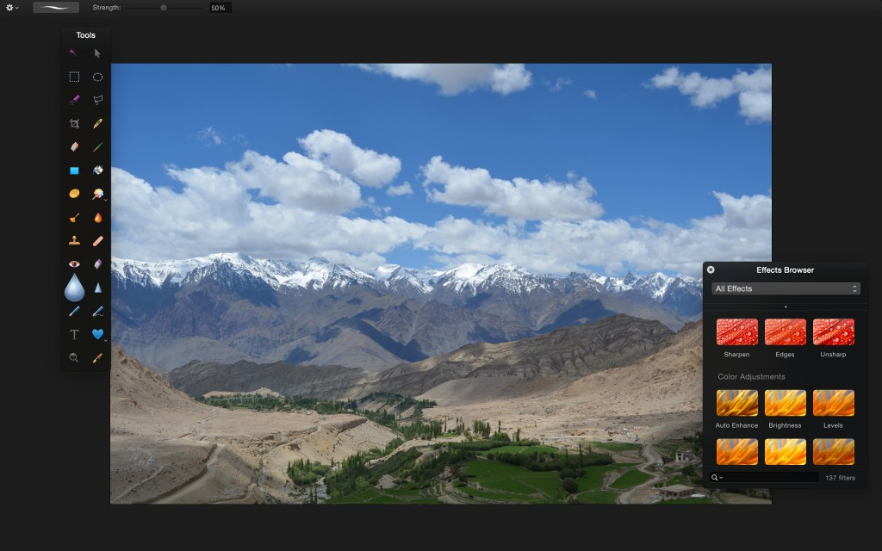](https://www.firstuploads.com/wp-content/uploads/2015/10/Screen-Shot-2015-10-01-at-3.16.38-pm.jpeg)

This application is targeted to the intermediate level of users , with great tools & better UI for naïve users. This application ticks all the important requirements.

Recently Pixelmator has been updated to the Version 3 which packs more advancements over the earlier versions of the Applications.

It is even priced right at around $40 , so it doesn’t burn any hole of the consumers compared to the Adobe Photoshop , Lightroom Suites costing 10 equivalent software price.

It also has Automator Scripts for some automation on batch images in Apple “Automator” App.

**Application Link:**

<http://www.pixelmator.com/mac/>

**TweetBot**

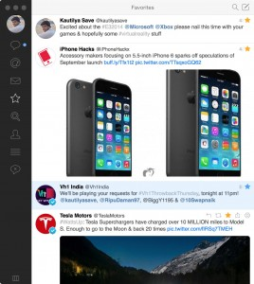

Home

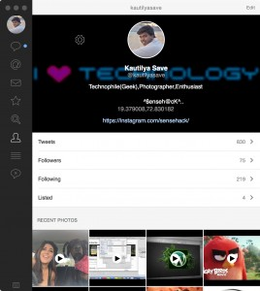

Profile

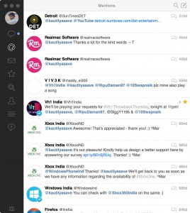

Mentions

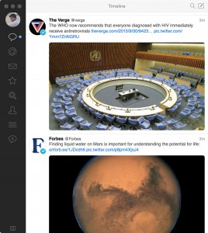

Feed

This is best twitter application one can get on Apple Ecosystem.

This Twitter application delivers it users a clean User interface with proper features for its price.

It supports TweetBot for iPhone , iPad & Mac.

It supports multiple users login within the application , which could be used for quick switching between different users.

**Application Link:**

<http://tapbots.com/tweetbot/mac/>

**Fantastical 2**

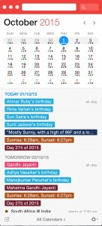

Desktop Windows Floating

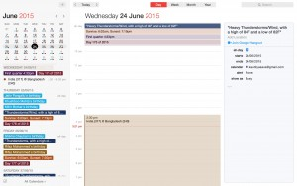

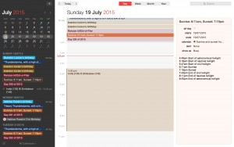

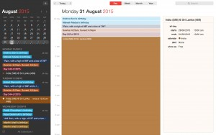

This is also one of the application which has perfectly made keeping track of appointments & calendar events a great task.

Tracking birthdays of friends is also easy , with notes & reminder configurations also available.

This application has two modes of operation in themes “Day mode” (Light Mode) or “Night Mode” (Dark Mode). I personally prefer Dark Mode as it saves a considerable amount of battery when using it for significant amount of time.

**Application Link:**

<https://flexibits.com/fantastical>

**iA Writer**

The only minimalistic writer you would ever need.

This is the standard of how the word processors should have been in the first place.

The text editors shouldn’t show all the features on its front page rather it should focus on the writing new content & not distracting the writer.

This application also supports two theme working modes. “Day mode” (Light Mode) or “Night Mode” (Dark Mode). I personally prefer Dark Mode also on iA Writer as it saves a considerable amount of battery when writing articles for an hour or so.

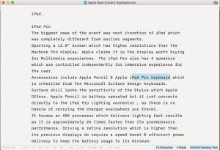

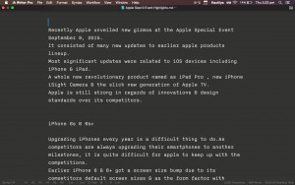

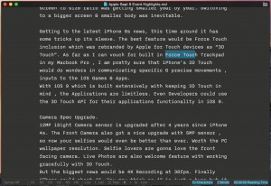

**Application Link:**

<https://ia.net/writer/mac>

**iStudiez Pro**

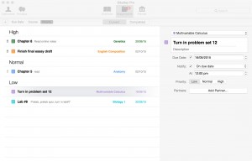

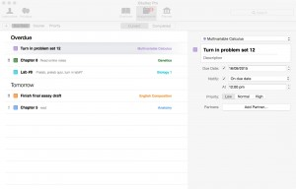

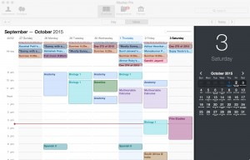

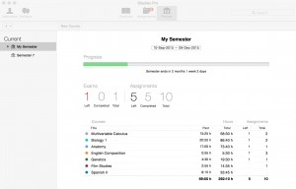

Need to manage the studies which are been conducted at your university or college / school.

No Need to look around , iStudiez Pro is the perfect solution to track all the lectures , assignments , homework , teachers , holidays etc.It provides an overview of the student track record of studies performed or attended by him.How many days still left for the semester & how many lectures he didn’t attended.His marks average to calculate overall Pointer.

The best thing is it is supported on all Apple ecosystem. Application downloadable on iPhone , iPad & Mac OS X.

**Application Link:**

<https://itunes.apple.com/us/app/istudiez-pro/id402989379?mt=12>

With these Top Ten Exclusive Mac Application , we hope that this article has some what lured you into trying one of these Mac Exclusive Applications. If you want to mention any Exclusive app in the honourable section of the article , do share your views in the comments below or contact us. Remember always support the developer, as he/she has invested countless hours into making something beautiful for everyday usage.

Which one is your favorite Mac Exclusive app let us know in the comments section below.